EU-CANADA ALPS SUMMIT 2023

Val d’Isère - France
24 – 26 Mars 2023

Summary

Canada – Europe Economic Chamber - EU ………………………………………………………………………..………. 3
A word from the President ……….……………………...………………………………………………………………………..….. 4

EU-Canada Alps Summit 2023 ………..…..………………………………………………………………………..………..… 5

Program …………………………………………………………………………………………………………...…………………… 6

Registration …………………………………………………………………………………………………………...…………………… 7

The Resort ………………………………………………………………………………………………………………….……..…….....……… 8
Elite Premium Partners …………………………………………………………………………….………….… 10

The Canada-Europe Economic Chamber-EU

Based out of Brussels, capital of Europe and founded in September 2018, the Canada-Europe Economic Chamber-EU is to promote economic trades between Canada and the European Union. The CEEC-EU is the follow up of the Canada-Europe Economic Chamber in Canada created in February 2016.

Partnership with the CEEC-EU is open to all, from SMEs to large companies, with an interest in international trade and business development through Canada and the European Union.

The CEEC-EU is providing all the appropriate services for business looking to trade internationally.

The CEEC-EU is delivering high quality activities and initiatives that will help your business to connect, grow and succeed.

A word from the President

On September 21st, 2017 came into force a free trade agreement between Canada and the European Union: CETA.

Through this strategic alliance, Canada and the European Union are accepting several important challenges while opening up to new opportunities. This new economic dynamic reaching over half a billion people is an important symbol of the actual global economic reality. These two territories with common historical roots and strong values ​​are now called to collaborate more than ever before on business projects that can take place in Canada, in the European Union or anywhere else in the world.

It had therefore become essential to create a business hub in Brussels that could gather all the economic actors of the 27 countries of the European Union along with the ones from Canada.

I invite you to build this business community with me for the most fruitful cooperation between Canada and the European Union.

Hope to meet you soon.

Sam Ayoub
President
Canada – Europe Economic Chamber – EU

The EU-Canada Alps Summit

The EU-Canada Alps Summit is a splendid combination of professional presentations and quality networking. This year’s edition of the Alps Summit will be held from March 24-26, 2023 in Val d’Isère, France.

The participants made up of Canadian and European business leaders will meet at this exceptional setting to forge strong and long-lasting links during a friendly ski journey in the French Alps.

Several business experience testimonials will be presented at the EU-Canada Alps Summit from all participants. Also, topics to be discussed will be on the progression of business opportunities in Canada and Europe and how CETA is a key factor.

Activity:
EU-Canada Alps Summit Meeting 2022

Date:
March 24-26, 2023

Ski Resort:
Val d’Isère, France

Description:
Information activity and quality networking for Canadian and European business leaders in an exceptional setting.

Objectives:
- Encourage quality exchanges
- Establish long lasting personal and business relationships
- Relevant presentations EU-Canada.

Number of participants:
20

Cost of registration per participant:
Free for Partners and 195 Euros for others
(doesn’t include transportation, meals, accommodations nor access to the mountain)

Program

This year’s Summit is a two days event that will mark the progressive return of In-Person events after a too long pandemic situation all over the world. Scheduled at the end of the week, participants are more than welcome to extend there stay all along the week-end to deepen their business relationships and enjoy the exceptional ski resort of Val d’Isère. Several short business presentations will be asked to be performed by all participants.

Friday, March 24, 2023

8 pm - Greeting and welcome cocktail
8:30 pm – Introduction to the 2022 Summit Meeting + Business presentations
9:00 pm - Outing and meal in Val d’Isère

Saturday, March 25, 2023

9 am - Morning Skiing
12 O’clock - Lunch + Business presentation
1:30 - pm - Afternoon skiing
5 pm - Back to the chalet
8:00 pm – Drinks & Meal in Val d’Isère

Sunday, March 26, 2023

10:00 am – Brunch + Closing presentation

More Information:

Canada-Europe Economic Chamber - EU
Jules Lejeune Street, 24
1050 Ixelles
Belgium

Telephone: +32.0493.85.78.04
Info@canadaeurope.eu

Registration

Free for all Partners of the CEEC-EU

195 euros for others

Name : Canada-Europe Economic Chamber – EU
Bank : ING
IBAN : BE33 3632 0016 9846
BIC Code : BBRUBEBB
VAT : BE 0744.750.756

Registration is mandatory and must be send by email containing these information

Name
Title
Company name
Address
Telephone Number
Email

Please send registration at info@canadaeurope.eu before December 16th 2022

Important notice
-
Links to affiliated 3-4 stars hotels, ski tickets and other accommodations will be sent to you after registration.

The Resort

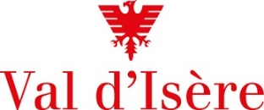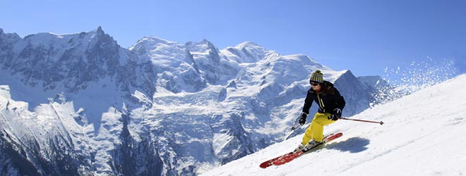

Located at the bottom of the Tarentaise Valley (in Savoie), only a few steps away from its neighbour Tignes, the ski resort of Val d'Isère is now considered one of the best ski destinations in France.

Val d'Isère owes its reputation above all to its range of luxury services accessible to all. Elegance, quality and well-being are the watchwords and attract skiers from all over the world every winter to take advantage of an exceptional area combining Olympic and World Cup slopes, a multitude of off-piste spots and a very wide variety of slopes.

Situated at an altitude of 1850m, its geographical location and relief offer numerous possibilities for exploring the mountain: The ski touring areas are equipped (marked out and secured) to ski serenely, several off-ski activities have been created to adapt to the current situation (mountain biking on snow, Moonbike, Snooc, mini snow bikes, golf on snow, dog sled rides, ice floating) and of course snowshoeing, guided tours of the village and treatments in the institute The restaurants, some of which are Michelin-starred, offer a wide choice of takeaway and/or delivery menus. Enough to recharge your batteries, fill up with oxygen and open spaces.

The strong points of Val d'Isère:

. Its vast choice of varied slopes up to high altitude

. The triptych of exposure + altitude + snow cover which guarantees a long ski season from the end of November to the first week of May

. Its ski in/ski out accommodation

. One of the best off-piste areas in the world

The strongest links are created
through a privileged contact

Elite Premium Partners

