Program
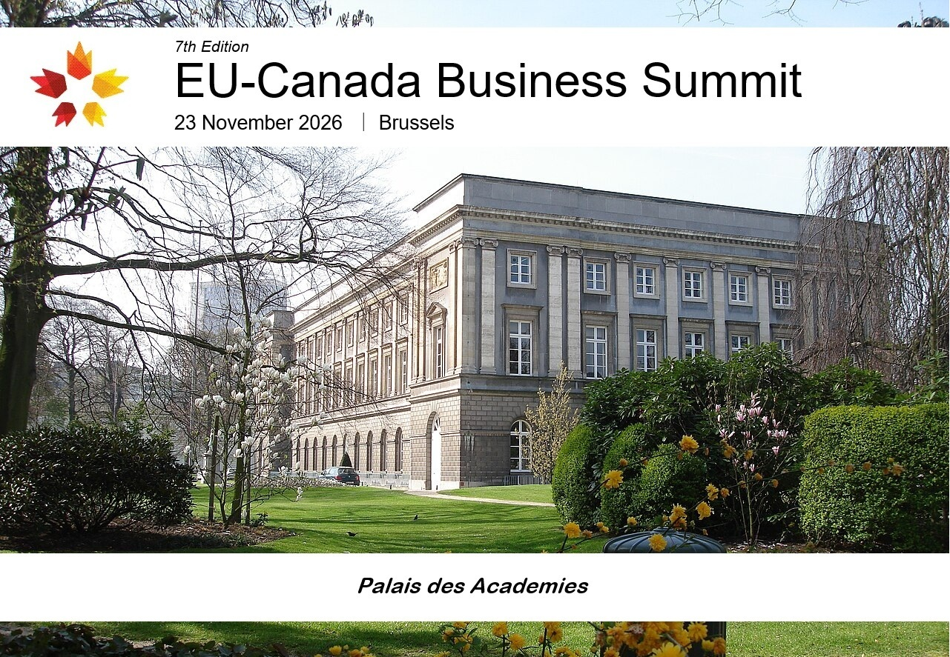

The EU–Canada Business Summit is the flagship annual gathering in Brussels that brings together hundreds of business leaders, policymakers, and institutional stakeholders from Canada, Europe, and across the globe. At a time of profound geopolitical and economic transformation, the Summit provides a unique platform to strengthen transatlantic partnerships, foster innovation, and advance cooperation in strategic sectors.

The 7th edition will be held at the prestigious Palais des Académies, in the heart of Brussels, reflecting the Summit's role at the centre of Europe’s political and economic decision-making.

Over the years, the EU–Canada Business Summit has provided a valuable platform to address the most pressing economic and strategic issues shaping Canada, Europe, and the global economy. This year, amid heightened geopolitical uncertainty, persistent trade tensions, and the reconfiguration of global supply chains, Canada and Europe have a unique opportunity to deepen their strategic partnership.

Reflecting the importance of this evolving agenda, a large share of the Summit's five panel discussions will focus on the defence sector and the opportunities arising from enhanced transatlantic cooperation. Strengthened collaboration is already taking shape through closer defence industrial ties, including Canada's growing engagement with European defence initiatives such as SAFE and its longstanding commitment within NATO. Beyond security, this renewed partnership is expected to accelerate cooperation in artificial intelligence, research and innovation, critical technologies, resilient supply chains, and market diversification—reinforcing economic competitiveness and collective resilience on both sides of the Atlantic.

The EU–Canada Business Summit offers a unique platform to build meaningful business relationships through high-level networking opportunities, including an exclusive cocktail reception, private B2B meetings and interactive panel discussions. This year's edition will also feature an exclusive VIP Dinner* at the prestigious De Warande business club, located just steps away from the Palais des Académies, bringing together senior business leaders, policymakers, and key stakeholders in an intimate setting designed to foster strategic dialogue and new partnerships. *Reserved for registered VIP participants only.

  40  Countries represented |   20  Number of  speakers |   500  Number of participants

12:00 – 12:25
Welcoming & Networking

12:25 – 12:30
Opening Keynotes
Sam Ayoub
President
Canada-Europe Economic Chamber – EU – Brussels

12:30 – 13:30
The Future of Transatlantic Security: Canada, Europe and NATO

The transatlantic security environment is undergoing profound change, with Europe taking greater responsibility for its defence while Canada reassesses its strategic role within NATO and in the defence of Europe. This panel will examine the future of Canada–Europe security cooperation in the context of NATO, the war in Ukraine, Arctic and North Atlantic security, evolving defence commitments and the changing role of the United States. It will explore how Canada and Europe can strengthen their partnership and contribute to a more resilient and capable transatlantic security architecture.

13:30 – 14:30
From Allies to Industrial Partners: Canada, Europe and the Future of Defence Procurement

The growing need to strengthen defence capabilities is creating an unprecedented opportunity for Canada and Europe to deepen their defence-industrial relationship. Canada's participation in the EU's SAFE programme opens new possibilities for joint procurement, investment, innovation and industrial cooperation. This panel will explore how Canadian and European companies can work together to develop more resilient defence supply chains, enhance interoperability and accelerate innovation in areas such as advanced manufacturing, AI, autonomous systems, cybersecurity and space, while reducing strategic dependencies.

14:30 – 15:00
Networking Break

15:00 – 16:00
The New Trade Wars: Canada, Europe and the Future of Global Commerce

Global trade is entering a period of profound transformation, marked by tariffs, protectionism, industrial subsidies, economic coercion and growing geopolitical competition. For Canada and Europe, the challenge is to diversify trade and strengthen economic resilience while remaining deeply integrated with the United States and other major global markets. This panel will examine the future of CETA, the evolving North American trade relationship, relations with China and other major economies, and the prospects for a more open and rules-based global trading system.

16:00 – 17:00
From Critical Minerals to Critical Partnerships: Building Canada–Europe Supply Chains

Critical minerals and strategic resources have become central to both economic competitiveness and national security, creating significant opportunities for Canada and Europe to build stronger and more integrated supply chains. Canada possesses substantial resources and expertise, while Europe has major industrial, technological and investment capabilities. This panel will examine how the two partners can move beyond the traditional trade of raw materials towards integrated value chains in areas such as batteries, clean technologies, energy, advanced manufacturing and defence, while improving supply-chain resilience and reducing strategic dependencies.

17:00 - 18:00
AI and the New Technology Race: Can Canada and Europe Compete in a World of Technological Superpowers?

Artificial intelligence and emerging technologies are rapidly reshaping the global economy, transforming industries while becoming increasingly important to national security and geopolitical influence. Canada and Europe have strong research capabilities, innovative companies and a shared interest in developing trustworthy and secure technologies but face intense competition from the United States and China. This panel will explore how Canada and Europe can strengthen their technological competitiveness through cooperation in AI, semiconductors, quantum technologies, cybersecurity, advanced computing and digital infrastructure, while balancing innovation, regulation, investment and strategic autonomy.

18:00 – 18:15
Closing Remarks
Sam Ayoub – President - Canada-Europe Economic Chamber – EU – Brussels

18:30 – 20:00
Cocktail Reception
20:00 – 22:00
VIP Dinner

Presented by
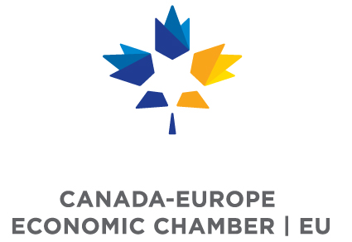

With the support of our Elite Partners & Sponsors

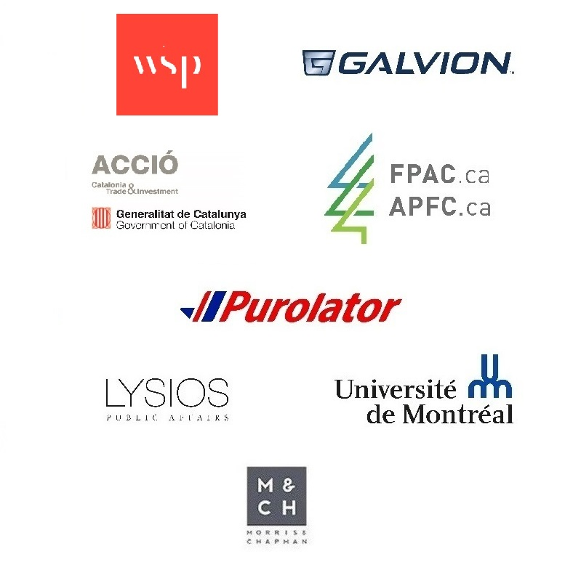

Communication sponsor



